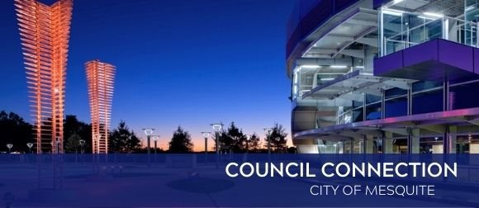
Dec. 29, 2023

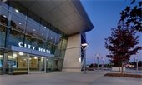

City Council to meet Jan. 2
Mesquite City Council meets at 7 p.m. on Tuesday, Jan. 2, at City Hall, 757 N. Galloway Ave. Members of the public, applicants and interested parties may attend the meeting in person. Members of the public desiring to comment during Citizens Forum must preregister by either sending an email to sland@cityofmesquite.com or calling 972-329-8388 before 3 p.m. on Jan. 2. Provide the City Secretary with your name and address. Comments on agenda items may be made during the meeting or by submission on or before 3 p.m. on Jan. 2 to the City Secretary. View meeting agendas online. The City broadcasts meetings via Facebook Live and at www.cityofmesquite.com/WatchCouncilMeetings.



Holiday closures and service impacts
City of Mesquite offices and facilities will be closed on Monday, Jan. 1, 2024 in observance of New Year's Day with the exceptions of Mesquite Metro Airport and Evans Recreation Center, which will be open from 2-6 p.m. All other recreation centers will be closed. No Commercial or Residential trash or recycling collected. Collection will resume on next scheduled collection day.



Celebrate safely to ring in the

New Year
The possession and use of fireworks in Mesquite is illegal, as is discharging firearms into the air. The penalties for fireworks and gunfire can be costly, with as much as a $4,000 fine and the possibility of up to one year in jail for the illegal discharge of a firearm, City fines and court costs up to $835 for the discharge of fireworks or $585 for the possession of illegal fireworks. Driving while intoxicated can lead up to $17,000 in fines, possible jail time and loss of a driver’s license. To report fireworks violations, call 972-204-4888, send an email to fireworks@mesquitepolice.org or fill out an online report at https://apps.cityofmesquite.com/police_web/report. Please do not call 911 unless there is a life-threatening emergency and immediate help is required from police, fire or paramedics.



Daddy Daughter Dance
Get your groove on at the annual Daddy Daughter Dance on Saturday, Feb. 17. The theme this year is Disco. The dance is for all ages and includes light snacks, refreshments, live music, professional photography, and themed selfie-stations. The dance will be held at the Mesquite Convention Center, 1700 Rodeo Drive. Tickets are limited and will not be sold at the door. Advanced ticket purchase is required. Tickets: $20 per person, per session. Session 1: 4 - 6 p.m. and Session 2: 7 - 9 p.m. Ticket sales begin Wednesday, Jan. 8, and may be purchased online at www.cityofmesquite.com/DaddyDaughterDance, at any recreation center or at the Parks and Recreation Administration Office, 1515 N. Galloway Ave.



Contact Us
Do you have a concern? Send requests for street repair, crime concerns, park issues and more from your computer or mobile device. For more details, visit www.cityofmesquite.com/myMesquite.

  Share on Facebook
  Share on Twitter
  Share via Email

  Copyright City of Mesquite. All Rights Reserved.
  1515 N. Galloway Avenue Mesquite, Texas 75149
  Powered by

