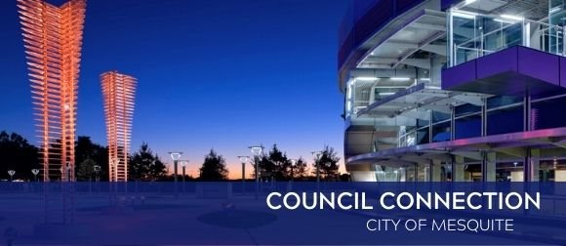
Nov. 17, 2023



City Council meet-and-greet and regular meeting on Nov. 20
Mesquite City Council meets at 7 p.m. on Monday, Nov. 20, at City Hall, 757 N. Galloway Ave.
The public is invited to a meet-and-greet reception at 6:30 p.m. with the recently elected Councilmembers and to attend the swearing-in ceremony at 7:15 p.m.
Members of the public, applicants and interested parties may attend the City Council meeting in person. Members of the public desiring to comment during Citizens Forum must preregister by either sending an email to sland@cityofmesquite.com or calling 972-329-8388 before 3 p.m. on Nov. 17. Provide the City Secretary with your name and address. Comments on agenda items may be made during the meeting or by submission on or before 3 p.m. on Nov. 20 to the City Secretary. View meeting agendas online. The City broadcasts meetings via Facebook Live and here.



Give input through Community Survey
The 2023 Community Survey is now open to the public. Residents are invited to provide input about the City of Mesquite's programs and services. The Community Survey is being administered by ETC Institute, a national leader in conducting customer satisfaction surveys for government organizations. Make your voice heard and fill the survey out here.

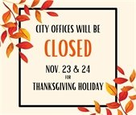

City of Mesquite offices to be closed Nov. 23-24
All City of Mesquite offices and facilities will be closed on Nov. 23-24 for the Thanksgiving holiday, with the following exceptions:
- Mesquite Metro Airport will be open both days.
- Trash will be collected on Friday, Nov. 24, but not on Thursday, Nov. 23. Recycling will not be collected either day.
- Recreation Centers will be open on Friday, Nov. 24.
- The Compost Facility and Convenience Center will be open on Friday, Nov. 24.
Click here to see the complete 2023 holiday schedule.



Visit Downtown Mesquite to shop small businesses on Nov. 25
Downtown Mesquite is once again an officially designated Neighborhood Champion for Small Business Saturday (SBS), which is Saturday, Nov. 25. SBS was created to put the spotlight on locally owned small businesses following the more corporate Black Friday. Participating Downtown Mesquite businesses will be open and will be promoted on digital media, with special signage, and other methods. Nov. 25 also will be the last Saturday of the Downtown Mesquite Farmers Market, which will focus on gift items. The Farmers Market is from 9 a.m. to 1 p.m. at the Front Street Station, 100 W. Front St.



Properly dispose of fats, oils and grease during the holidays
Don’t ruin your holidays with a sewer backup in your home. Fats, Oils and Grease (FOG) are the residue left over from cooking with food items such as meat, butter, lard, sauces, dressings, dairy products and cooking oil. FOG and debris poured down drains can build up and cause backups in both private and the City-maintained sewer system. To avoid expensive plumbing repairs and damage to the sewer system:
• scrape or wipe cooled grease or fat from all cookware and place in the trash; and
• pour or scrape grease into a sturdy closed-lid container and dispose in the trash.
Resident may recycle used holiday cooking oil for free at the City of Mesquite Convenience Center (3550 Lawson Road) or other nearby drop-off locations. Check out the Defend Your Drains website at www.DefendYourDrainsNorthTexas.com.



Real. Texas. Holidays. starts Nov. 28
Join City of Mesquite’s festive family-friendly events. Get in the holiday spirit with celebrations including everything from historic events with Father Christmas to a straight-out-of-a-movie tree lighting on the downtown square complete with gazebo. Experience Christmas in the Park with hot cocoa and free pictures with Santa, and savor the sights and sounds of the season at the Mesquite Arts Center with holiday plays and music from our local symphony and band. Enjoy a hometown holiday like none other in the Rodeo Capitol of Texas with Real. Texas. Holidays. Visit www.cityofmesquite.com/RealTexasHolidays for more information.
Christmas on the Square: Join us for the first celebration of the season in Downtown Mesquite. Christmas on the Square includes carols, cocoa, Santa and a tree-lighting ceremony in Downtown Mesquite Nov. 28 from 5 - 8 p.m. Find out more here.



Contact Us
Do you have a concern? Send requests for street repair, crime concerns, park issues and more from your computer or mobile device. For more details, visit www.cityofmesquite.com/myMesquite.

  Share on Facebook
  Share on Twitter
  Share via Email

  Copyright City of Mesquite. All Rights Reserved.
  1515 N. Galloway Avenue Mesquite, Texas 75149
  If you no longer wish to receive emails from us, you may Unsubscribe.
  Powered by

