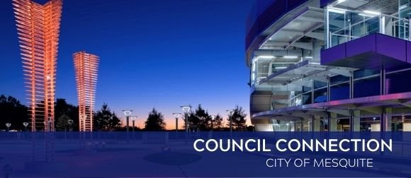
Nov. 10, 2023



Mesquite to hold annual Veterans Day celebration Saturday, Nov. 11
The City of Mesquite, in partnership with American Legion Post 504 and VFW Post 8785, will host a Veterans Day event to celebrate the bravery and service of our military heroes. The Veterans Day Celebration will be at 11 a.m. on Saturday, Nov. 11, at Mesquite Veterans Memorial, 425 S. Galloway Ave. Visit www.cityofmesquite.com/VeteransDayCelebration for more information.

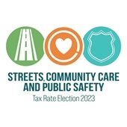

63% of voters approve Proposition A
Voters approved the City of Mesquite’s Proposition A measure that will provide funding for roadway and alley reconstruction, additional police officers, a new fire station, staffing and equipment to operate the fire station, and a new Behavioral Health Division. Voters approved the measure by 63 percent. In August, the Mesquite City Council unanimously approved the City’s 2023-24 budget that necessitated an increase in the tax rate of $0.03186 per $100 ad valorem value. State law requires voter approval of the tax rate increase due to the additional revenue exceeding the tax cap of 3.5 percent. The canvassing of election results is on the Nov. 20 City Council agenda.



2023 Municipal Election results
Mayor Daniel Alemán, Councilmember Jeff Casper (Place 1), Councilmember Kenny Green (Place 2) and Councilmember Tandy Boroughs (Place 4) ran unopposed and were automatically re-elected. Councilmember B.W. Smith (Place 5) was re-elected. The election also had historic results with the two newly elected Councilmembers. Brandon Murden (Place 6) is the first African American resident elected to the Council, and Elizabeth Rodriguez-Ross (Place 3) will be the first Hispanic woman to serve on the Council. More than 7,600 voters cast ballots choosing Mesquite City Councilmembers, according to preliminary results. The canvassing of the results is on the Nov. 20 City Council agenda, and all the Councilmembers will be sworn in for the new term.



City officials, business leaders celebrate Texas' Site Selection ranking
Because of Mesquite’s contributions to the state’s economic success, City of Mesquite and Hexagon Purus officials were invited to participate in a celebration on Nov. 1 announcing Texas being ranked as the “Best Business Climate in the Nation” by Site Selection Magazine. “Thanks to Mesquite's efforts and the important announcement from Hexagon Purus, Texas continues to uphold our status as the nation’s premier destination for business,” said Adriana Cruz, Executive Director for Texas Economic Development and Tourism. “Our thanks go to Mesquite for all you do to keep Texas the nation’s leader for job creation and the best state for business.”



Register Now for Turkey Camp
Over Thanksgiving break, students in K-6th grade can spend a day or the whole week playing games, creating holiday crafts, and experiencing other fun activities. Turkey Camp will be available at Dunford Recreation Center, 1015 Green Canyon Drive, from 7 a.m. to 6 p.m., Nov. 20 - 24 (no camp on Thanksgiving Day, Thursday, Nov. 23). A Teen Turkey Camp for students in 6th-8th grade also will be held. Pricing, dates and location are the same. The fee is $20 per day (per resident) and $30 per day (per non-resident). Also, a one-day Turkey Camp for kids K-6th grade will be held Nov. 20 at Rorie-Galloway Day Camp for more adventurous kids. Pricing is $25 per day for residents and $35 per day for non-residents. Register online at www.cityofmesquite.com/HolidayCamps.



Real. Texas. Holidays. starts Nov. 28
Join City of Mesquite’s festive family-friendly events. Get in the holiday spirit with celebrations including everything from historic events with Father Christmas to a straight-out-of-a-movie tree lighting on the downtown square complete with gazebo. Experience Christmas in the Park with hot cocoa and free pictures with Santa and savor the sights and sounds of the season at the Mesquite Arts Center with holiday plays and music from our local symphony and band. Enjoy a hometown holiday like none other in the Rodeo Capitol of Texas with Real. Texas. Holidays. Visit www.cityofmesquite.com/RealTexasHolidays for more information.
Christmas on the Square: Join us for the first celebration of the season in Downtown Mesquite. Christmas on the Square includes carols, cocoa, Santa and a tree-lighting ceremony in Downtown Mesquite Nov. 28 from 5 - 8 p.m. Find out more here.



Contact Us
Do you have a concern? Send requests for street repair, crime concerns, park issues and more from your computer or mobile device. For more details, visit www.cityofmesquite.com/myMesquite.

  Share on Facebook
  Share on Twitter
  Share via Email

  Copyright City of Mesquite. All Rights Reserved.
  1515 N. Galloway Avenue Mesquite, Texas 75149
  Powered by

